LACUATA, Ara Belle P.

2ECE-C

#Function 1 (Is Word Guessed)

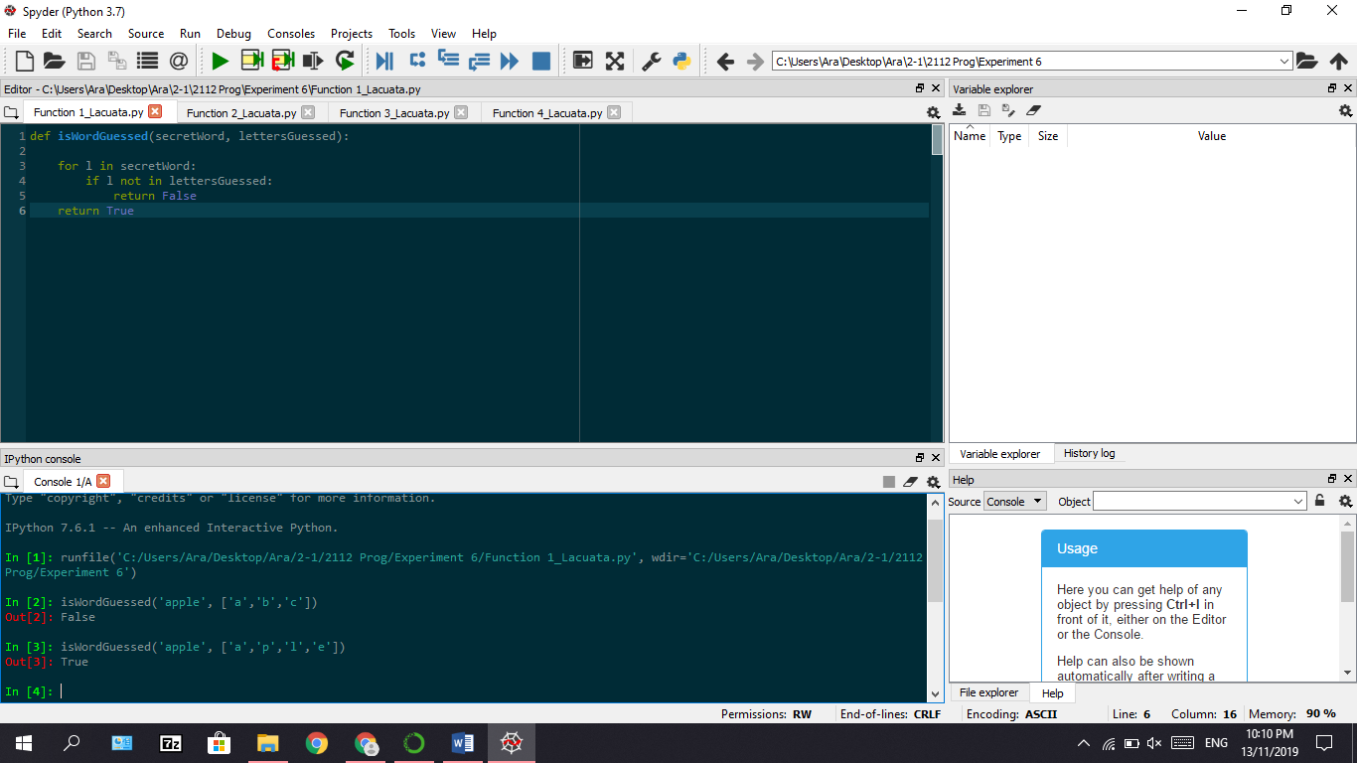

#Function 2 (Get Guessed Word)

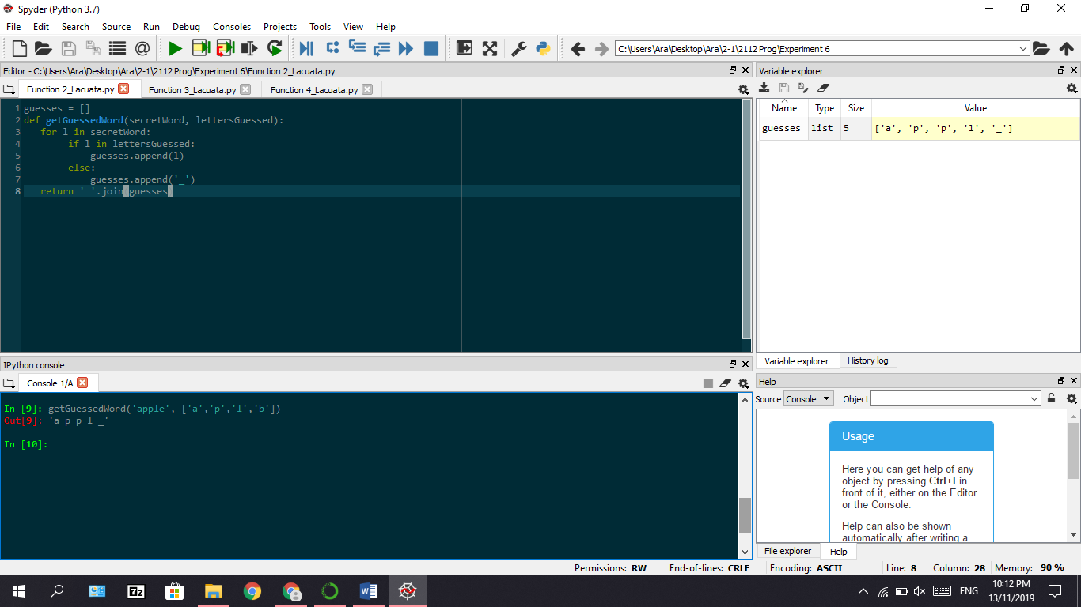

#Function 3 (Get Available Letters)

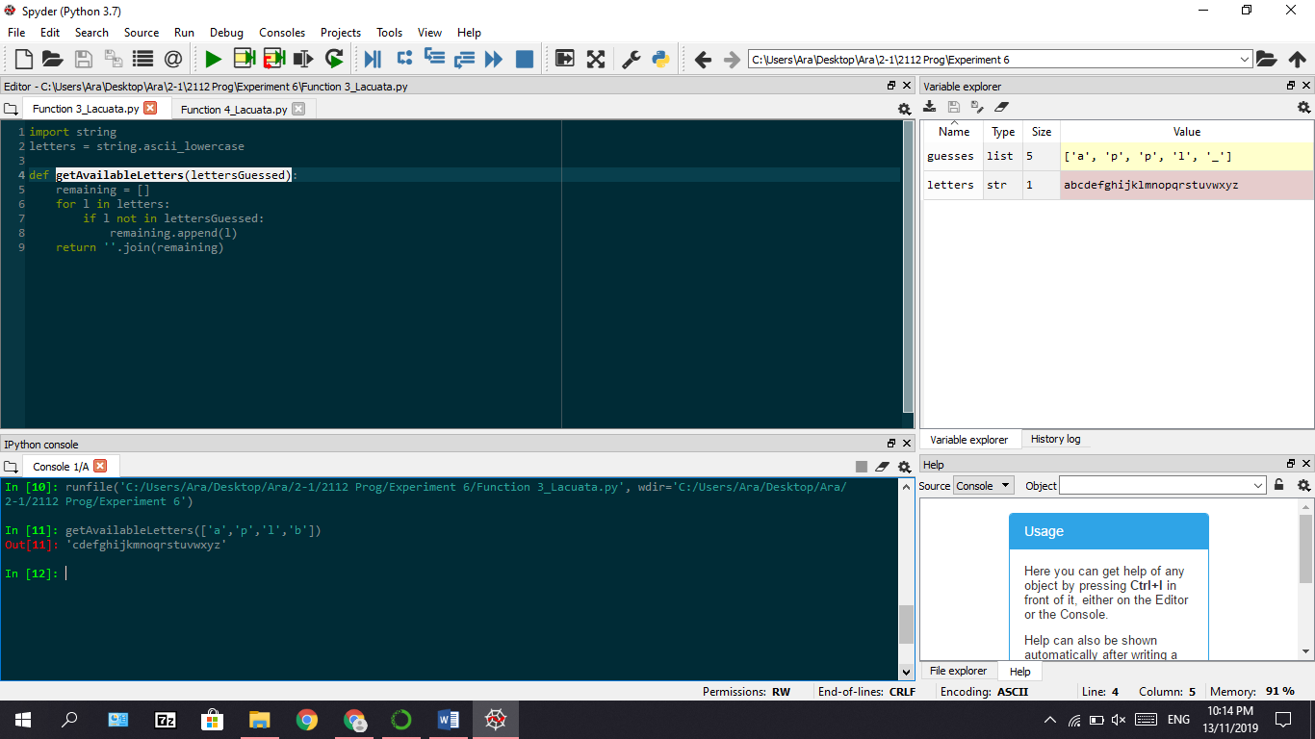

#Function 4 (Hangaroo)

